## Introduction

The Oak Compact Joystick is a midsized joystick compatible with the XAC or other analog input joystick devices. It has a range of toppers that can be 3D printed as well.

Up/Forward Arrow

## Features

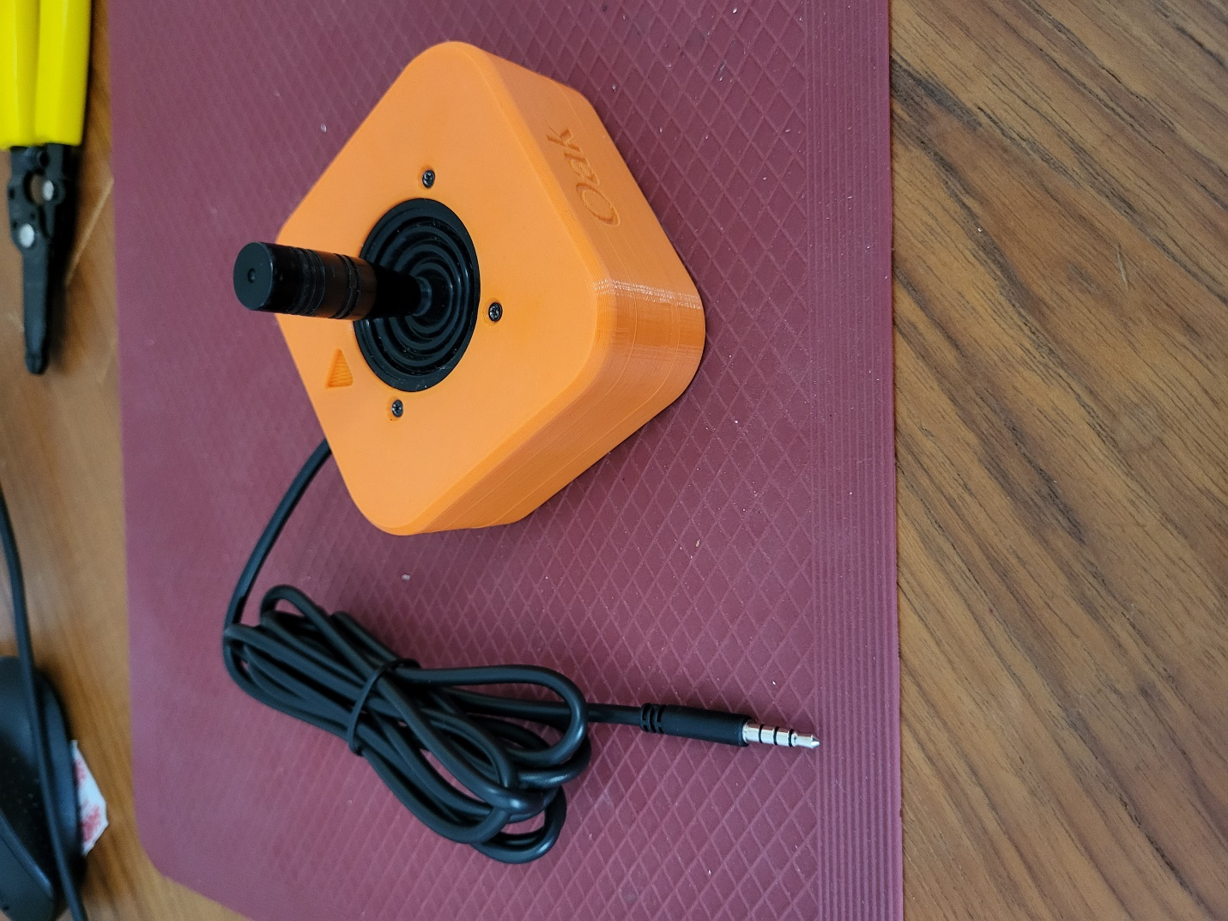

TRRS Cable Output

Oak Joystick

## Usage

### Using the Joystick

1. Plug the 3.5 mm TRRS cable from the joystick into the host device analog joystick input (such as the Xbox Adaptive Controller). If using the Xbox Adaptive Controller, plug it into X1 to use at the left joystick, or plug into X2 to use as the right joystick.
2. Ensure the arrow on the joystick is pointing in the “up/forward” direction, away from the user.
3. Mount the device if needed (see below).
4. Move joystick as you would with a standard controller (forward, left, backward, right).

### Compatibility

This device is compatible with the [Xbox Adaptive Controller (XAC)](https://www.xbox.com/en-CA/accessories/controllers/xbox-adaptive-controller), [Forest Hub](https://github.com/makersmakingchange/Forest-Joystick-Mouse-Hub), [Enabled Controller](https://makersmakingchange.com/project/enabled-controller/), [Enabled Controller Mini](https://www.makersmakingchange.com/s/product/enabled-controller-mini/01tJR0000006991YAA), and any other device that accepts a TRRS analog joystick input.

## Setting up the Joystick

Installation and removal of toppers as well as a brief explanation of mounting options are detailed in this section.

### Changing the Topper

The current range of Oak Joystick Toppers.

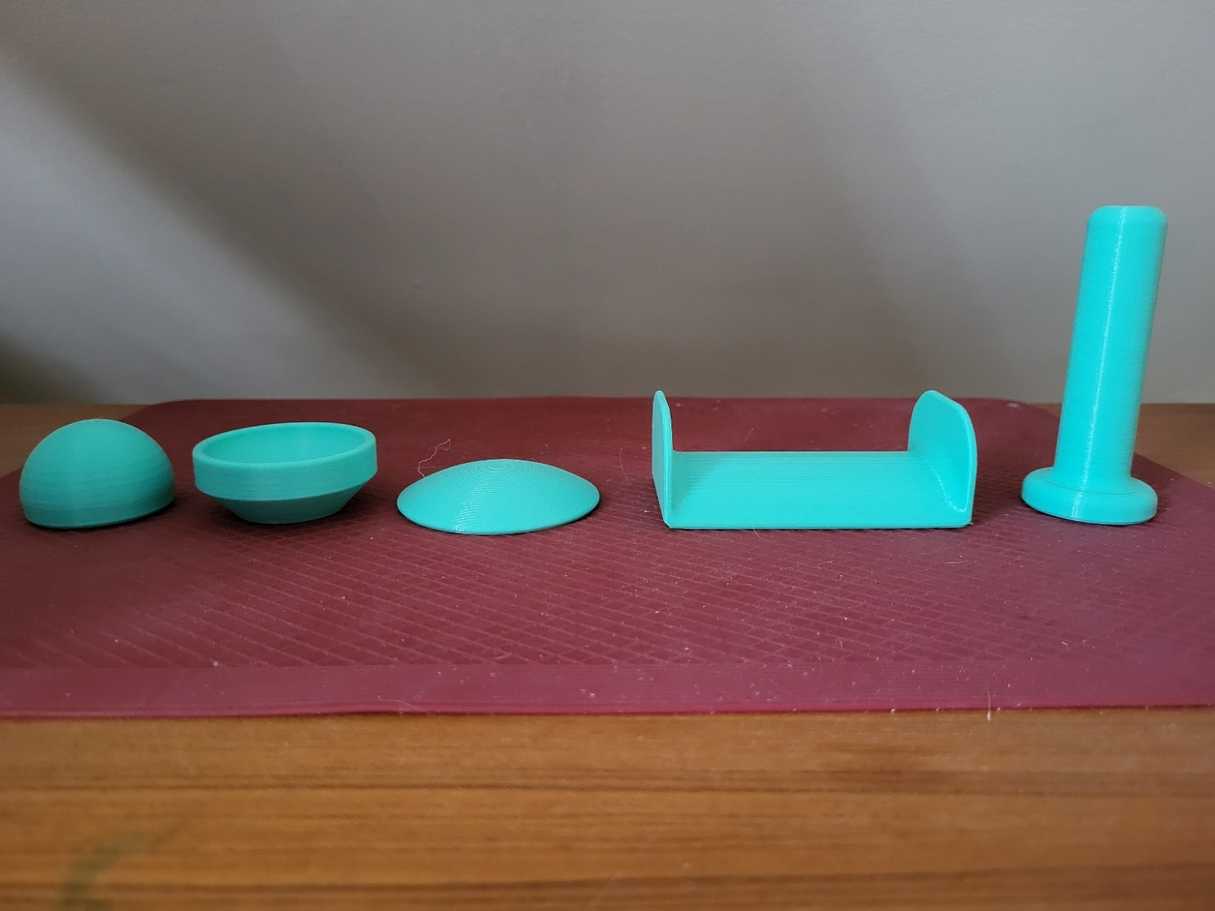

Ball Concave Convex Goalpost Stick

Installing and replacing the topper requires three components: the topper, the nut, and the collet.

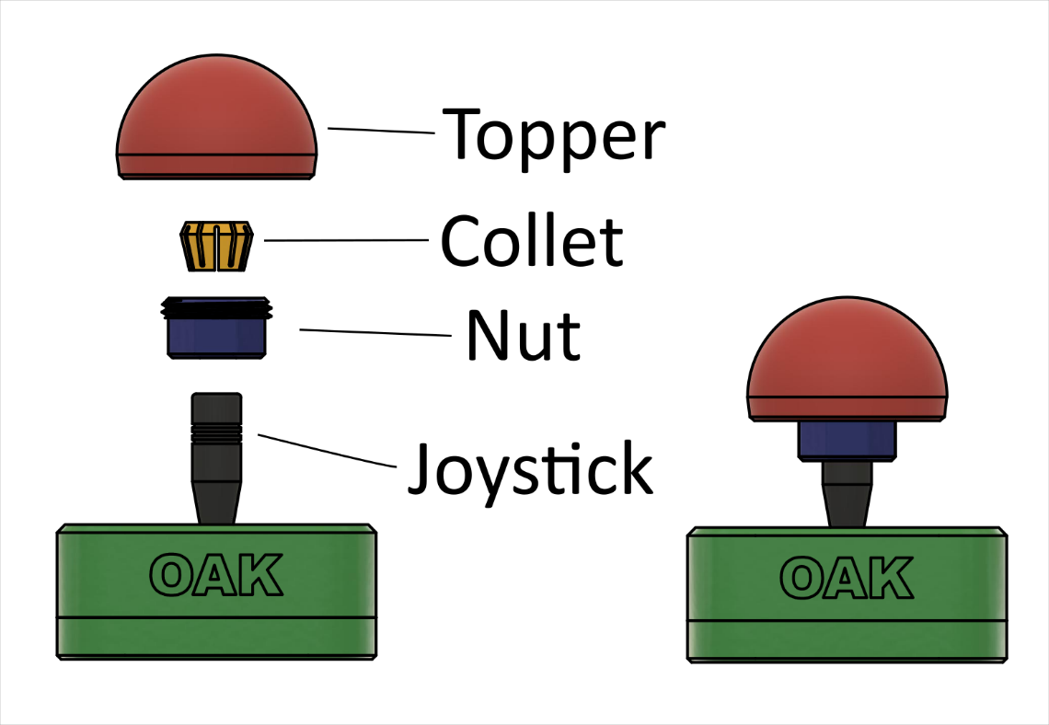

##### Step 1: Add Nut

|  |  |
| --- | --- |
| Place the nut over the black joystick shaft. The threads should be towards the top of the joystick, while the octagonal section should be towards the bottom. | A photo of the first step to installing a topper on the Oak Joystick. |

##### Step 2: Install Collet

|  |  |
| --- | --- |
| Place the collet on the black joystick shaft. The two ends of the collet have different thicknesses to them. The side of the collet that is thinner should go over the joystick shaft first, so that the thicker side is pointing up and away from the joystick. Note: if the collet does not sit at least ¾ of the way into the nut in this orientation, then the collet is likely upside down. | A photo of the second step to installing a topper on the Oak Joystick. |

##### Step 3: Fasten Topper

|  |  |
| --- | --- |
| Slide the nut up the joystick shaft just under the collet and line up the threads on the bottom of the topper with the nut. Thread the nut into the topper and tighten by hand. | A photo of the third step to installing a topper on the Oak Joystick.A photo of the ball topper installed on the Oak Joystick. |

To remove the topper, simply unscrew the nut and remove the topper. Note that you may require pliers or a wrench to grip the octagonal bottom of the nut if the topper is screwed on too tight.

### Mounting the Joystick

The Oak Compact Joystick can be mounted using various methods, depending on your preference and how you can best access it. See the [OpenAT Joystick Setup Guide](https://github.com/makersmakingchange/OpenAT-Joysticks/Resources/OpenAT_Joystick_Setup_Guide.pdf) for more information on different ways to mount the joystick. A few options are:

1. Tabletop
   1. Alone
   2. With non-slip pads
   3. With hook and loop fasteners (such as Velcro)
2. Using a mount adapter
   1. Camera mount adapter used with camera mount, or any mount with ¼-20 threads

**Note**: The mounting options are shown on a different joystick but will apply the same to this one.

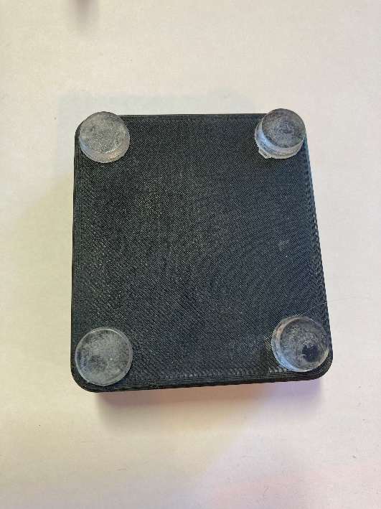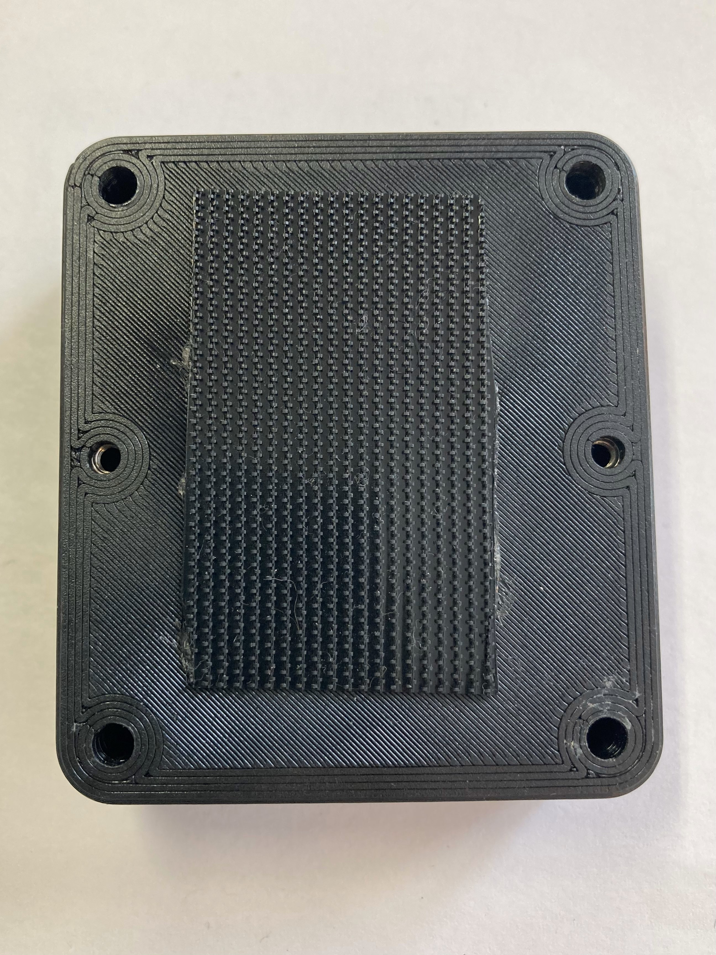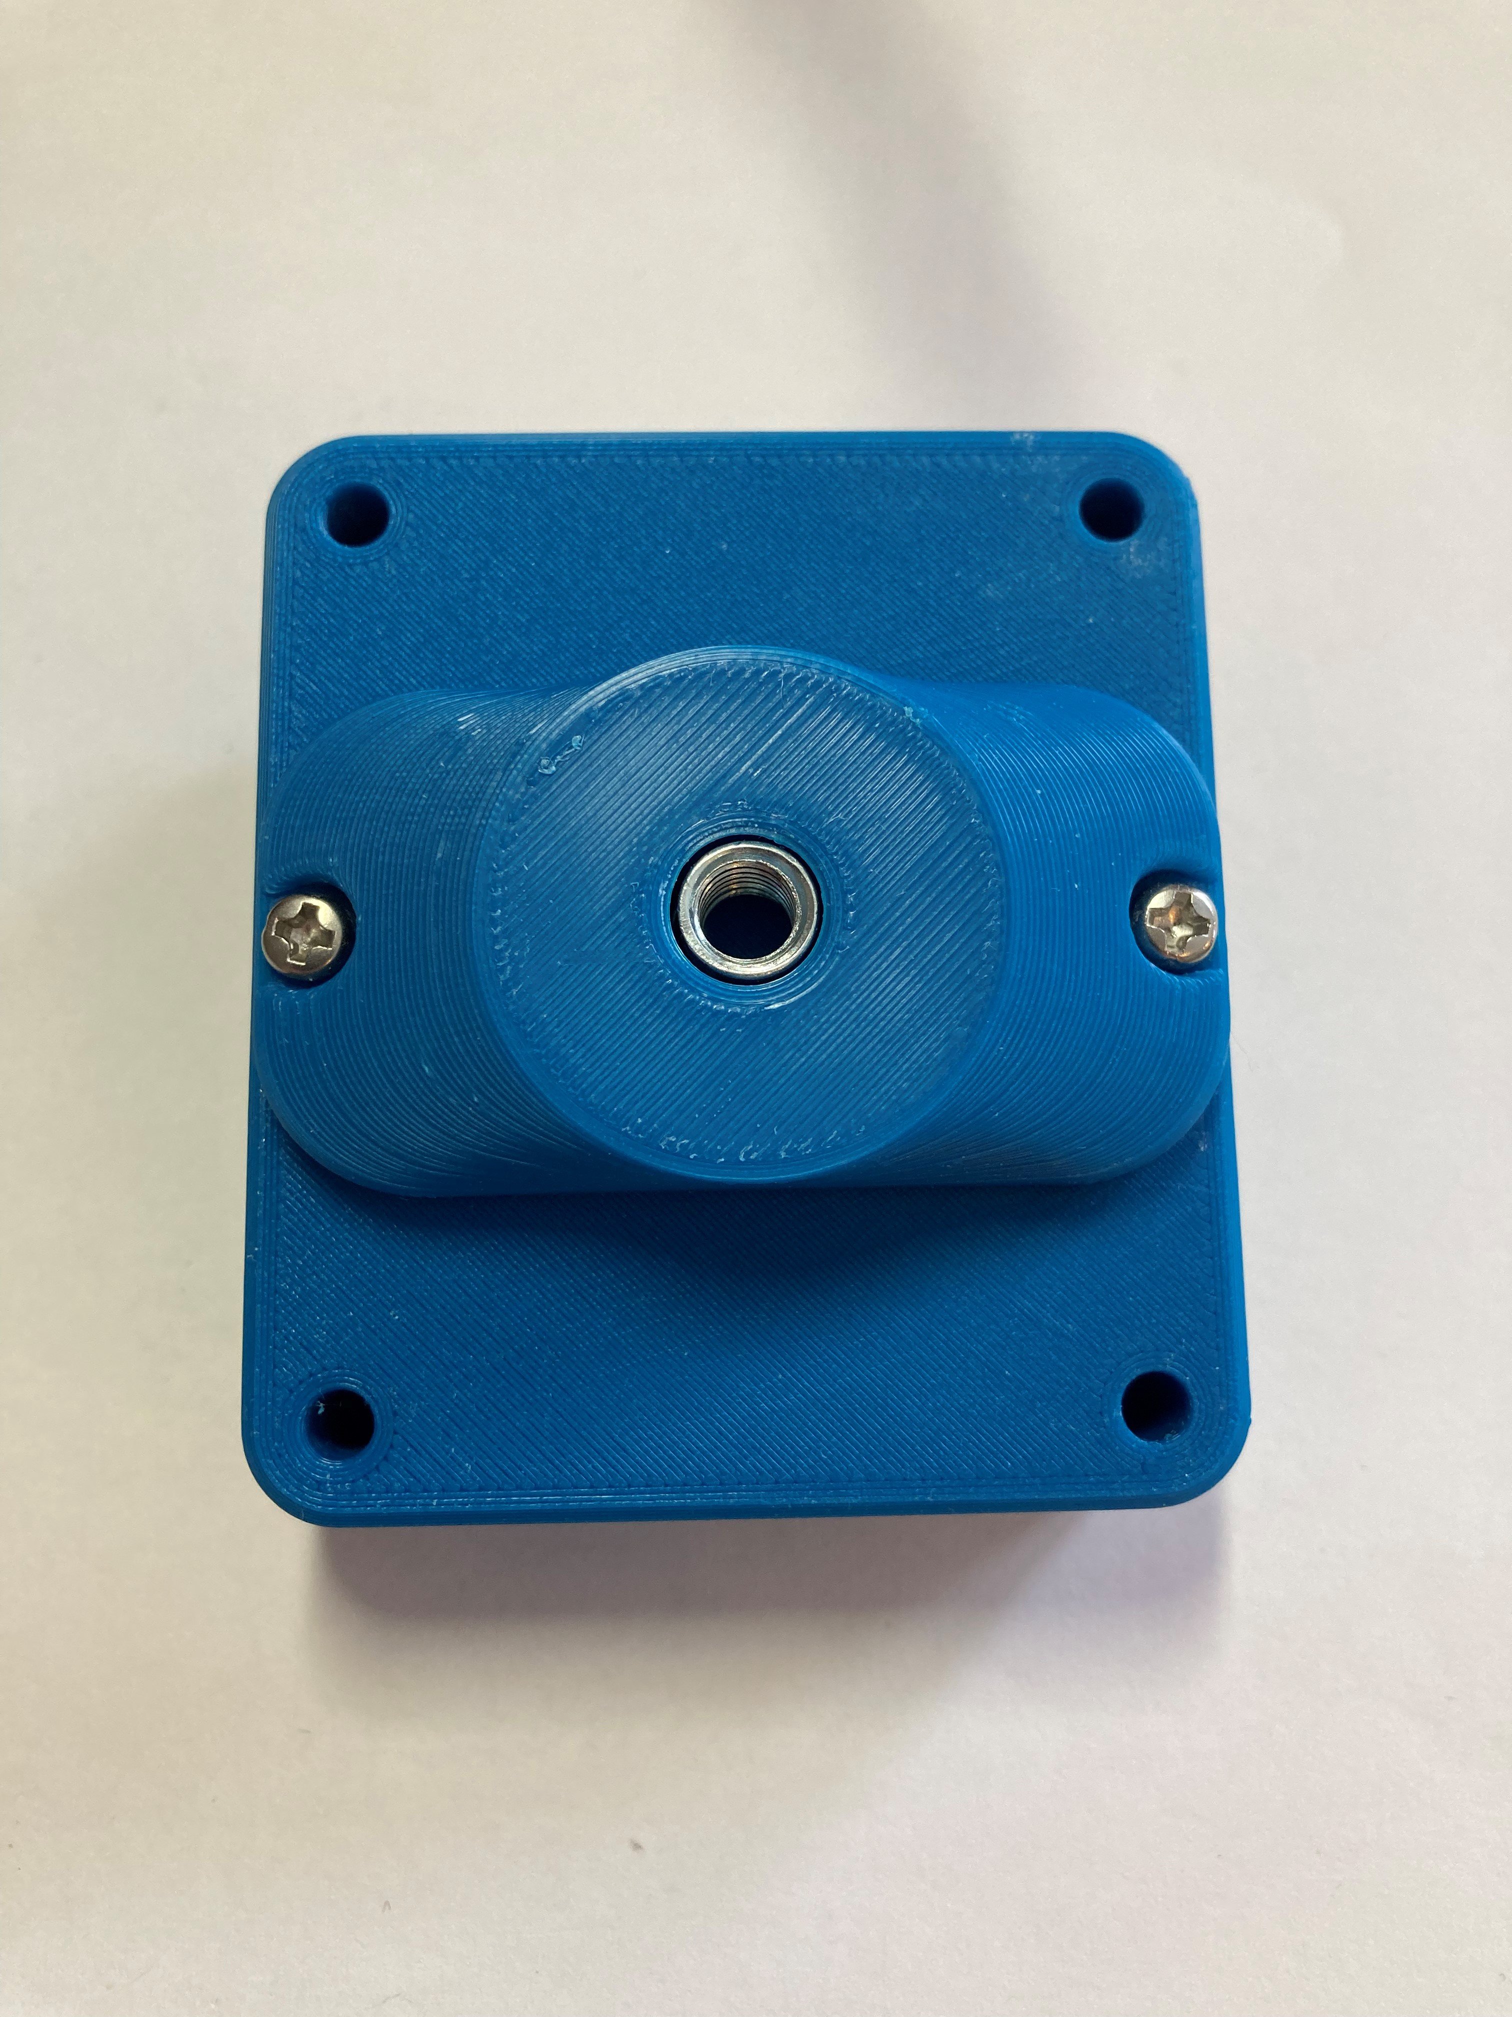

## Specifications

|  |  |
| --- | --- |
| Joystick Range of Motion | ± 25° |
| Joystick Range of Motion at Tip | ± 30 mm (default, changes with topper) |
| Joystick Activation Force | 525 grams |
| Total Height | 65 mm |
| Enclosure Height | 34.4 mm |
| Enclosure Width | 80 mm |
| Enclosure Length | 80 mm |
| Weight | 152 grams |

## Cleaning

Wipe the outside of the device with a lukewarm, damp cloth. Do not use hot water on this device or the plastic housing may warp. Do not submerge the device.